Episode 1- Planning for Assessment

Observation guide:

How did the teacher plan for?

- Structuring instruction in order to reinforce productive learning?

My resource teacher creates an interactive instruction to promote productive learning. It helps the student learn from peers and teachers to develop social skills and abilities, to organize their thoughts, and to develop rational arguments. My resource teacher strategy is giving them always a group activities and I think it is effective because the students easily understand the given topic. The success of the interactive instruction strategy and its many methods is heavily dependent upon the expertise of the teacher in structuring and developing the dynamics of the group.

- Differentiating instruction in order to challenge beliefs or ideas that create problems or inhibit the next stage of learning?

Not all students can catch up easily with the instructions that the teacher will give to them so this method of instructions can benefit to students not only with high abilities but also to those with learning disabilities. Differentiating Instructions may mean teaching the same material to all students using a variety of instructional strategies, or it may require the teacher to deliver lessons at varying levels of difficulty based on the ability of the student. My cooperating teacher did was having a group activity which the student can choose what is his/her desired interest, topic, or ability to do.

- Obtaining rich and detailed information about how students are progressing?

The teacher plan for obtaining rich and detailed information about how students are progressing is having a step by step process. She wants that her students can cope with the desired objectives she wants. And by that, she patiently teach them and make assessment in order to know the levels of comprehension her students have.

- Measuring the level of students’ learning, so that reasonable decisions can be made about students?

The teacher measured them through a kind of assessment, like for example a formative assessment in order to evaluate how someone learning is being progressed throughout the discussion. The teacher wants to know if her students understand freely the given topic of what she discussed. This assessment can conclude if a student is attentively listened to the teacher and also if she/he wants to cooperate in a given task.

Documentation

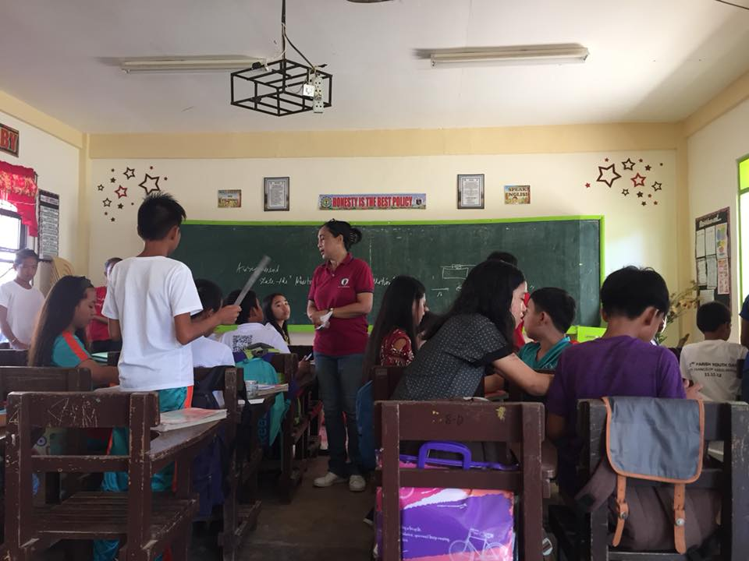
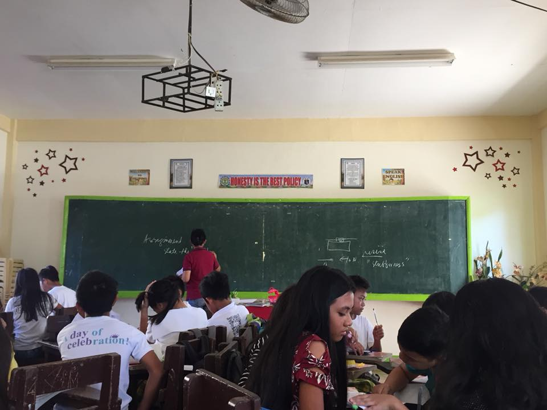
With Mrs. Suruiz measuring her students understanding about her topic of Newton’s Law of Motion.
GRADE-8

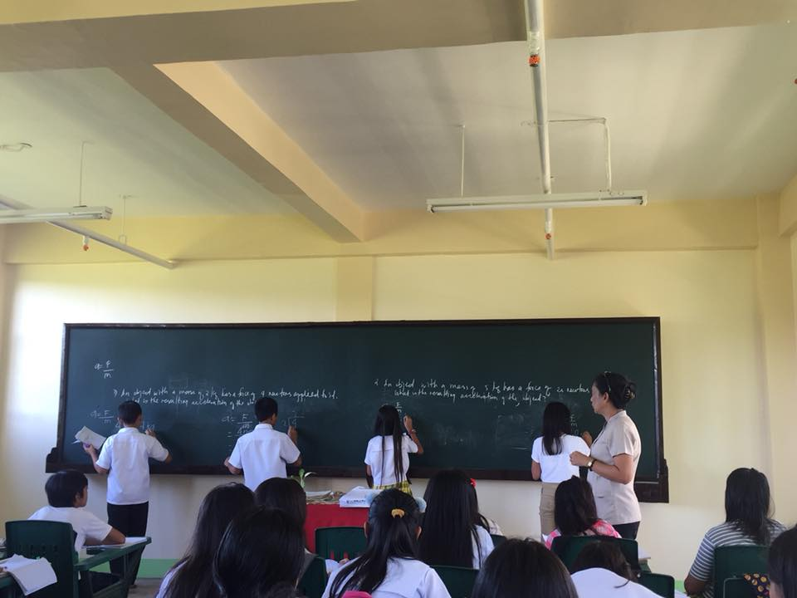

Measuring how the students progressing
With Mrs. Sajulga and the Grade 7- RUBY

Episode 2- Assessment Targets

Observation guide:

What are the teacher’s considerations in preparing for assessments that:

- Will expose students’ thinking and skills in relation to the intended learning?

Teachers should considered the appropriateness level of difficulty of the learners especially when it comes to instructions, it should be clear to students in order for them to fully understand the given problem.

- Can monitor students’ goal-setting process to support, challenge, adjust, and advance their learning?

Teachers should consider by taking into account the situational factors influencing student learning. Consider class size, prerequisites, the typical student profile and if the class is a requirement. Consider also the nature of the subject and the type of thinking you will be asking students to accomplish since preparation involves establishing what it is you want students to learn and how they will go about learning.

- Enable students to show the complexity of their understanding, apply key concepts, knowledge, skills, and attitudes in ways that are authentic and consistent with current thinking in the knowledge domain?

The teacher should consider the situational factor of students then it should be recommended that the teacher should use the backward design process to organize the course. Backward course design ensures that all of the lectures, learning activities, assignments, and test if fit together in a way that motivates the students engages them in learning that moves beyond the rote memorization of facts. It also provides evidence that a student are achieving the course goals and desired outcomes.

Documentation

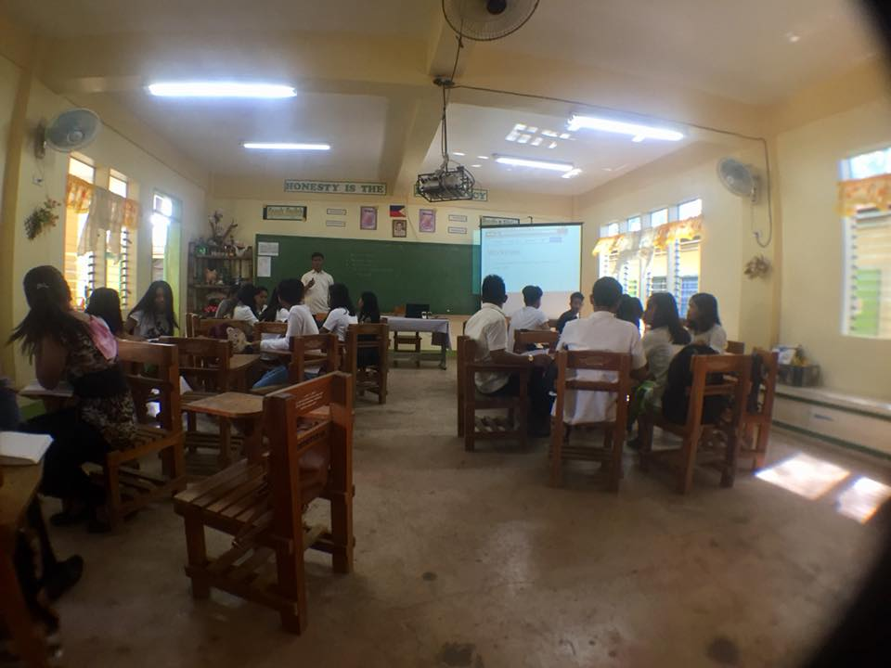
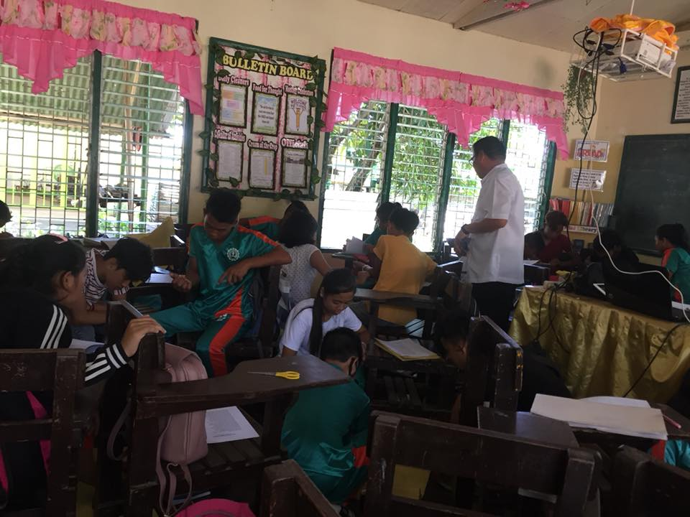
With Mr. Paglinawan
With Mr. Bayang

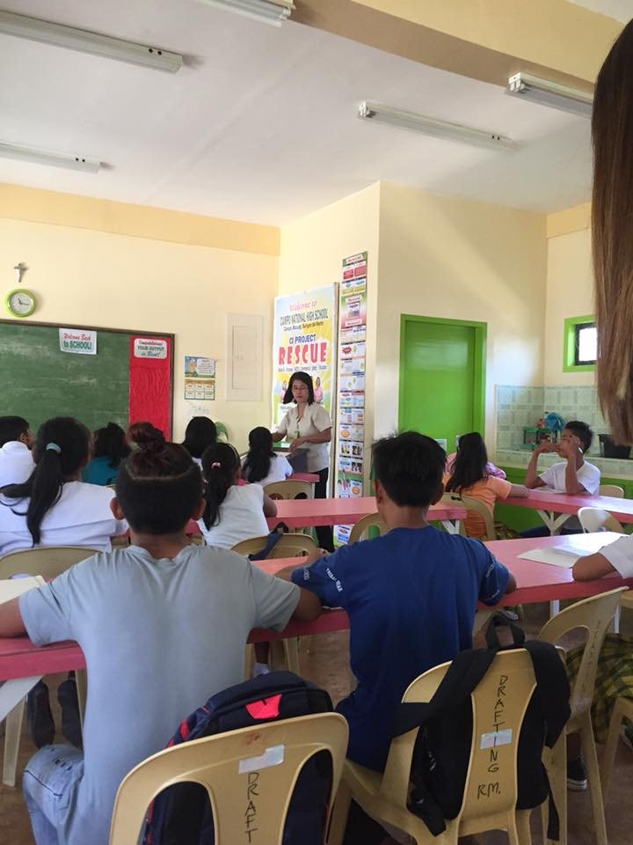
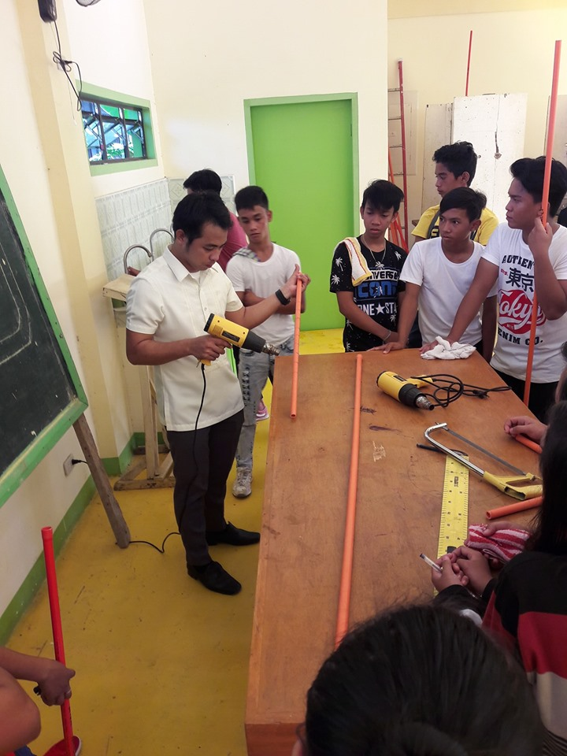
With Mrs. Sunipa Drafting Adviser
With Mr. Francia Electrical Adviser

Episode 3- Type of Assessment Tools

Observation guide:

What assessment method did the teacher use in order:

- To give the teacher the information that will be useful for planning and teaching?

The assessment method that the teacher should use is the reflective student essay. This method can be used as an assessment method to determined student understanding of course content and or issues as well as students opinions and perceptions. Teacher should know first what type of student she/he have so that the teacher can adjust what type of assessment or strategies she/he can give to the students.

- To elicit detailed information both about students’ learning and about their metacognitive processes?

The assessment method that the teacher will be using is the Pre and Post Tests. It typically an exam that administered at the beginning and at the end of a course or program in order to determine the progress of student learning.

3. to show students’ understanding and produce sufficient information to support credible and defensible statements about the nature and quality of their learning, so that others can use the results in appropriate ways?

Observations and Performance method can be should because Observation method is an information that can be collected while observing “events” such as activities, classes, social gatherings, group work, study sessions, etc. Observations also can provide information of student’s behaviours and attitudes. Performance also can be evaluated on participation in campus and/or community events, volunteer work, presentations, clinical, internships, musical or arts performances, etc. The performance of students is rated/scored using a rubric/scoring guide.

Documentation

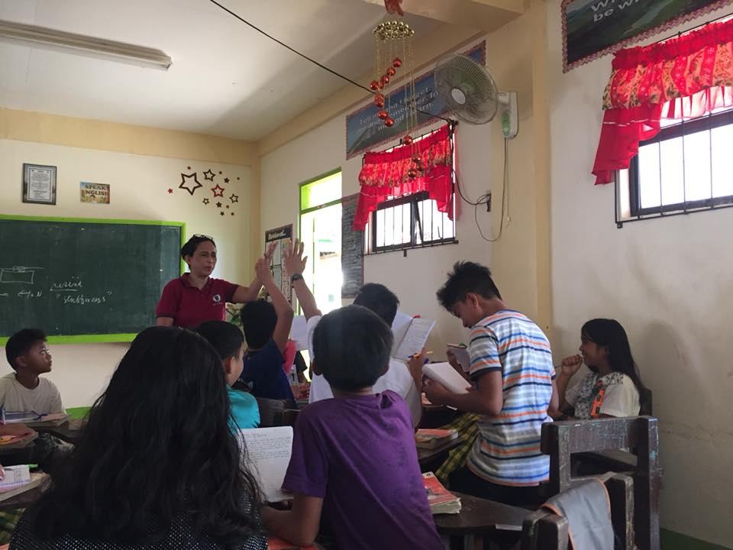
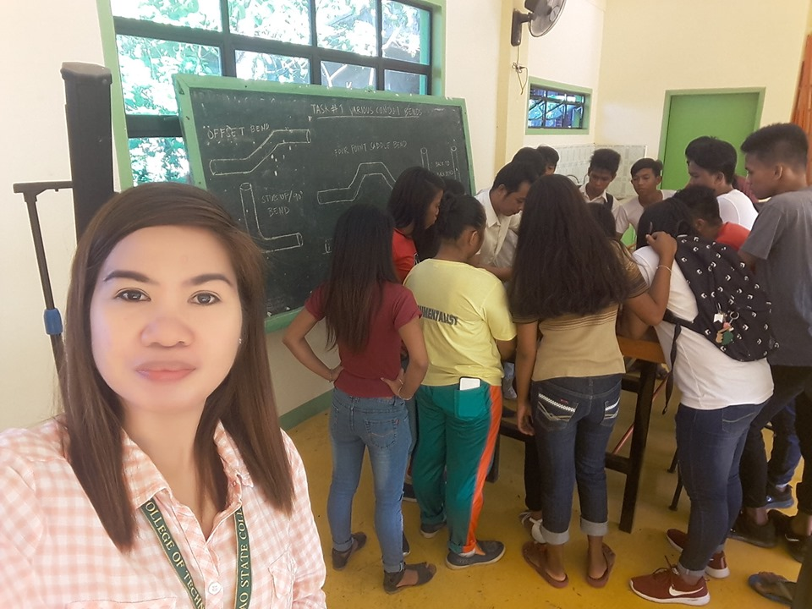

With EIM Students GRADE-12
With The Science Student Grade 9

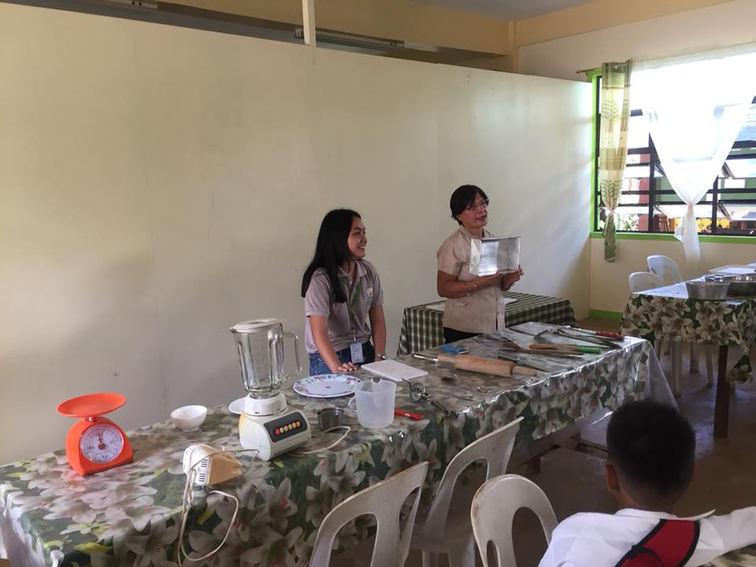

With Mrs. Lofranco TLE Adviser

Episode 4- Ensuring quality

Observation guide:

How did the teacher manage to use assessment results in order to meet the following:

- Reliability of information in actually getting a clear picture of how the students are thinking and what it is that students understand or find confusing?

The example of reliability in classroom is having a quiz to measure students ability, my resource teacher give them an activity about solving the geometric ratio and she assume that her students can solve the problem correctly and also the other items in the given activity because she assumed that her students understand what is being discussed.

- Curriculum learning outcomes?

Curriculum Outcomes is the development, dissemination, and implementation of relevant and effective curriculum. Expected learning outcomes can improve teaching and learning what should know and do. The knowledge and skills the students can should acquire by the end of a particular course.

- How did the teacher ensure that assessment can shed light on students understanding of the ideas that are contained in the learning outcomes and in the effectiveness of the choices?

The teacher ensure that the lesson or topic is clear to the students. The students should know what the learning objectives of the given topic is. My resource teacher ensure that the topic being discussed is in line and students can participate well. They can also relate it with their experiences and everyday life.

- How did the teacher manage to keep records to show whether the student work is on track and, when it is not, raise questions about the instruction and ways it could be adjusted?

The teacher did was facilitating what is being discussed. Sometimes she is the one to show and guide her students what the right thing to do. When the instructions does not clear to her students she repeat it until they can manage to get the right information and instruction.

Documentation

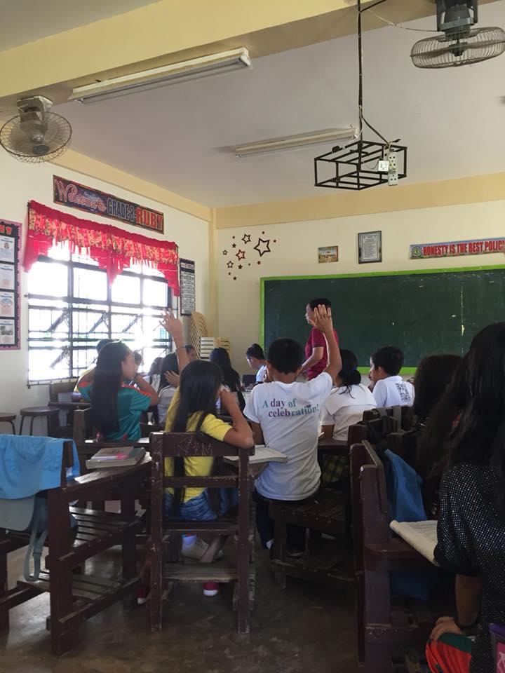

Episode 5 - Decision Making

Observation guide:

How the teacher did use the information from assessment in order to

- Provide Feedback to Students?

Providing feedback is just one job that teachers do to help students onto the path of success. My resource teacher in providing feedback to her students is she use correct and direct feedback to her students because it helps inexperienced and struggling students with a particular task.

- Differentiate Learning?

My resource teacher differentiate learning by creating a group activity which the students can shared interest, topic, or ability for the given task. She also manage classroom to create safe and supportive learning environment.

- Report assessment results?

We only have 1 week of observing in our cooperating school and in that case I don’t have an idea of what is really the method of the teachers in reporting an assessment but I assumed it lies on the performance of every student in her class.

Documentation

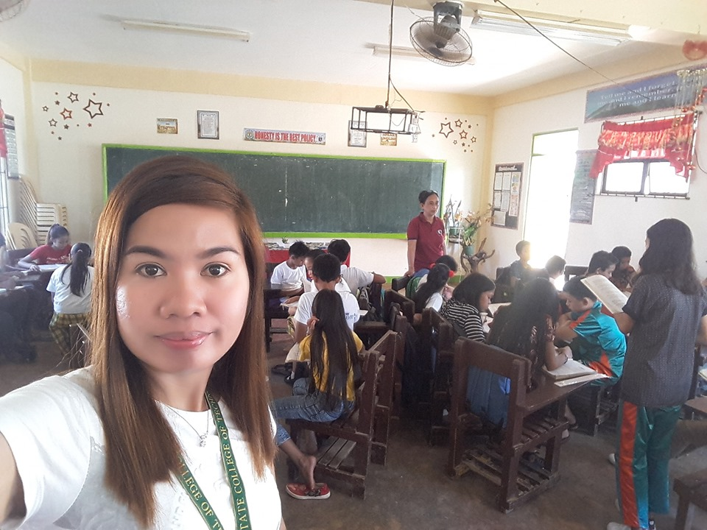

Episode 6- REFLECTION

Based on your observation, if you are the teacher handling the class, how will you use assessment to determine the differences in your students’ learning needs and how this influence the instruction that follows?

If I were a teacher I will ensure that I’m well-prepared in handling my lessons, organizing my topic of what I want to teach to them with their interest, it should be clear and concise and have a patience always. In that manner classroom management is much important to be an effective teacher. I will know and observe my students first before jumping to conclusion. Teachers are much more than just an authority figure to their students. I’m going to have the ability to manage time, build a relationship with my students, and structure their learning environment that is equal for all. I will find appropriate ways to help them especially that every students have their individual differences to help them learn better. Effective teachers strive to motivate and engage all their students in learning rather than simply accepting that some students cannot be engaged and are designed to do poorly. They believe that every student is capable of achieving success at school and they do all they can to find ways of making each student successful.

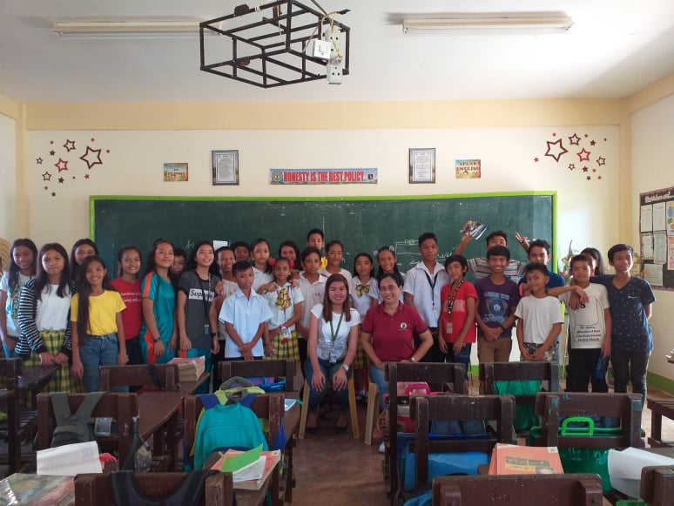

Episode 7- SELF-ASSESSMENT TOOLKIT

After the duration of the Field Study,

- What do I think I know about assessment?

Assessment is refers to strategies design to confirm what students know, demonstrate whether or not they have met curriculum outcomes or the goals of their individualized programs, or to certify proficiency and make decisions about students future programs or placements.

- What do I want to know about assessment?

I want to know about assessment is how it can affect every learners in everyday living, how the skills will allow them to face a world that is continually changing. I want also to know the changes in the skills base and knowledge the students need. And also I want to know if truly the assessment for learning is biased.

- What have I learned about assessment?

I learned about assessment is it focuses on the opportunities to develop students' ability to evaluate themselves, to make judgements about their own performance and improve upon it.

Pictures

- Picture of the school
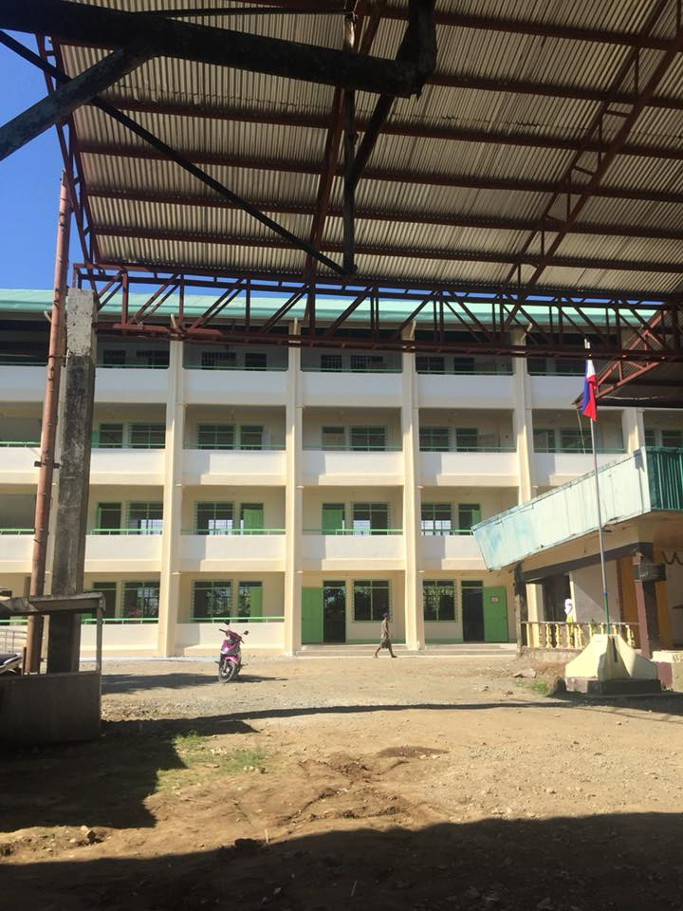
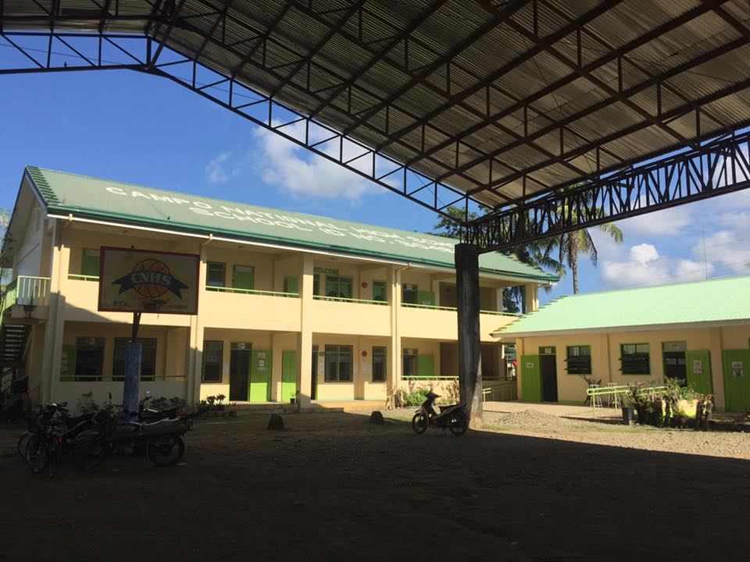

CAMPO NATIONAL HIGH SCHOOL

- Picture of the room

CNHS CLASSROOMS

- Picture of the principal
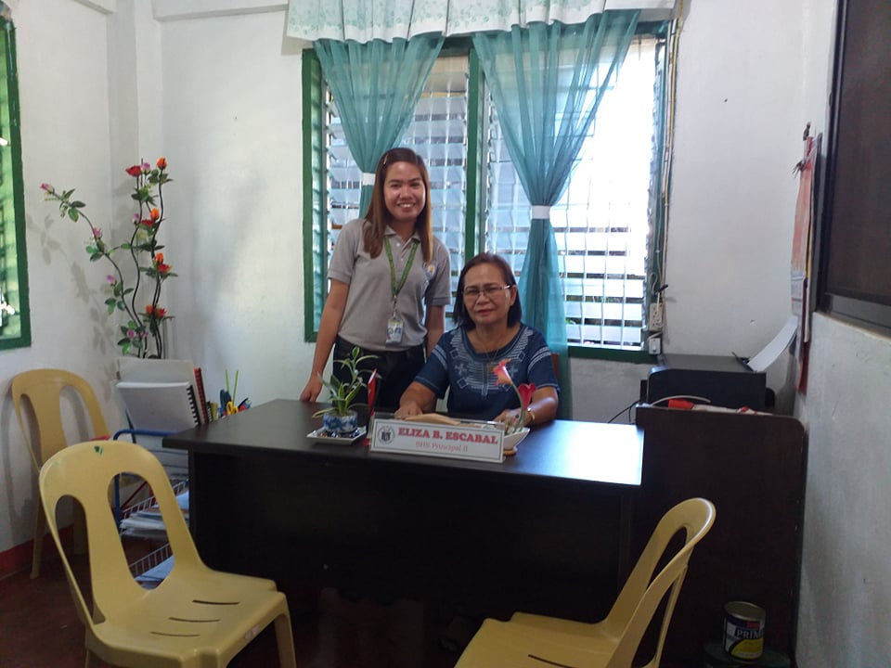
AT PRINCIPALS OFFICE WITH
MRS. Eliza B. Escabal
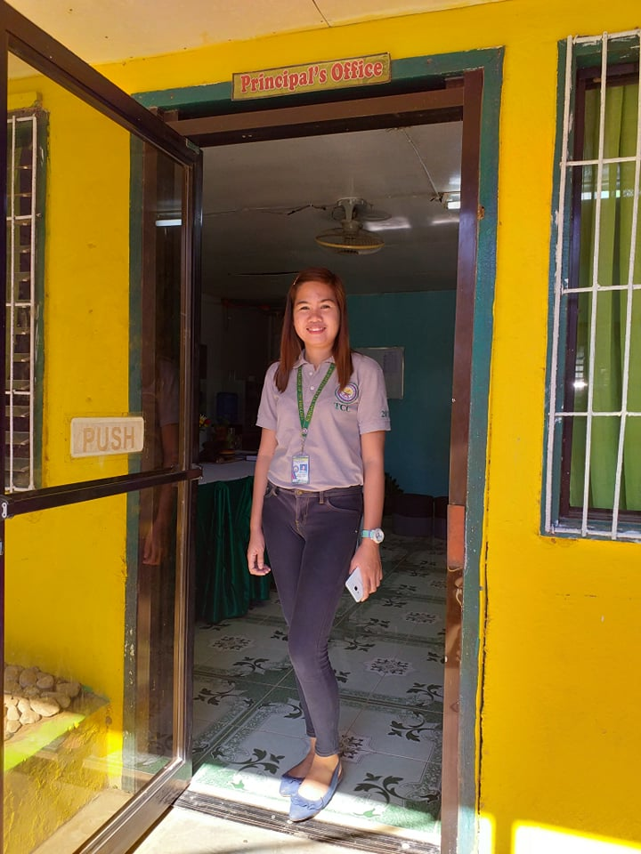

- Picture of the teacher facilitator

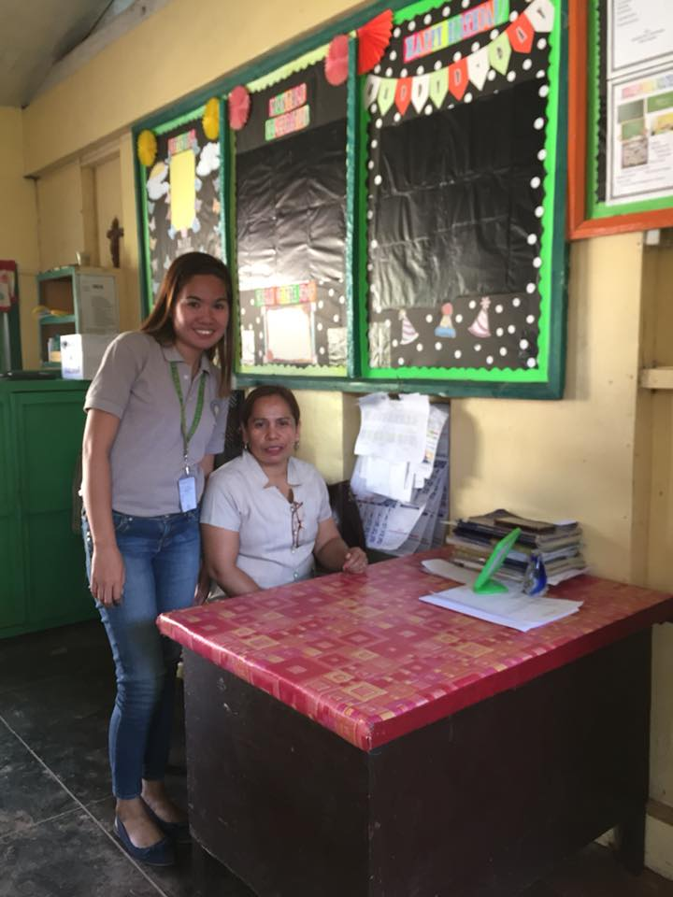

- Picture of the students

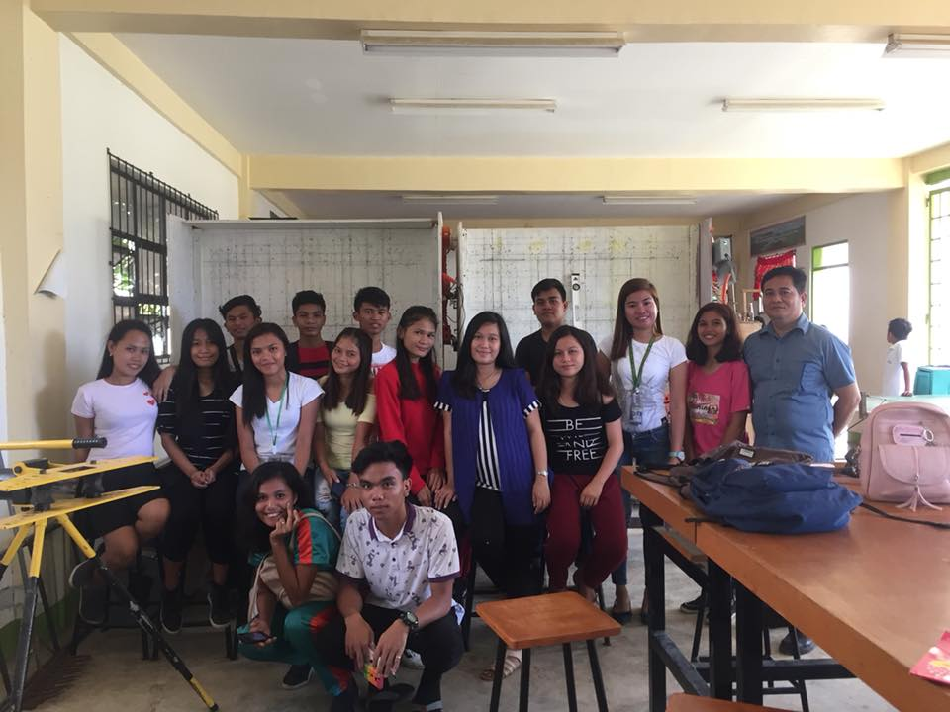
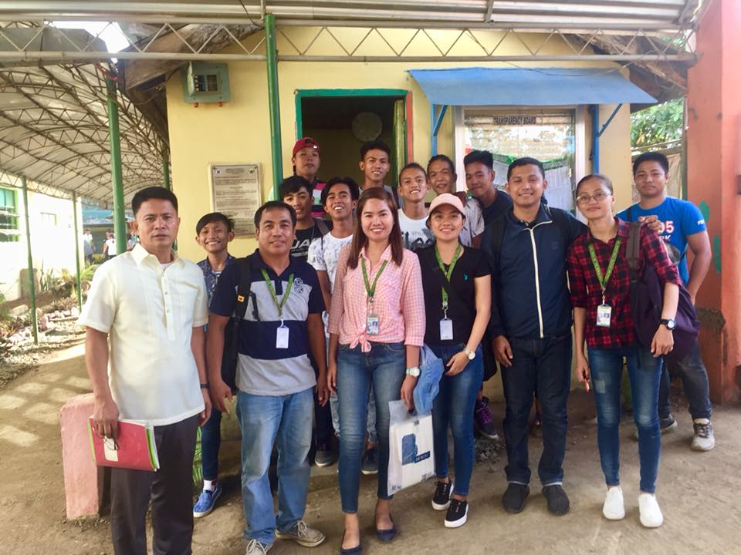

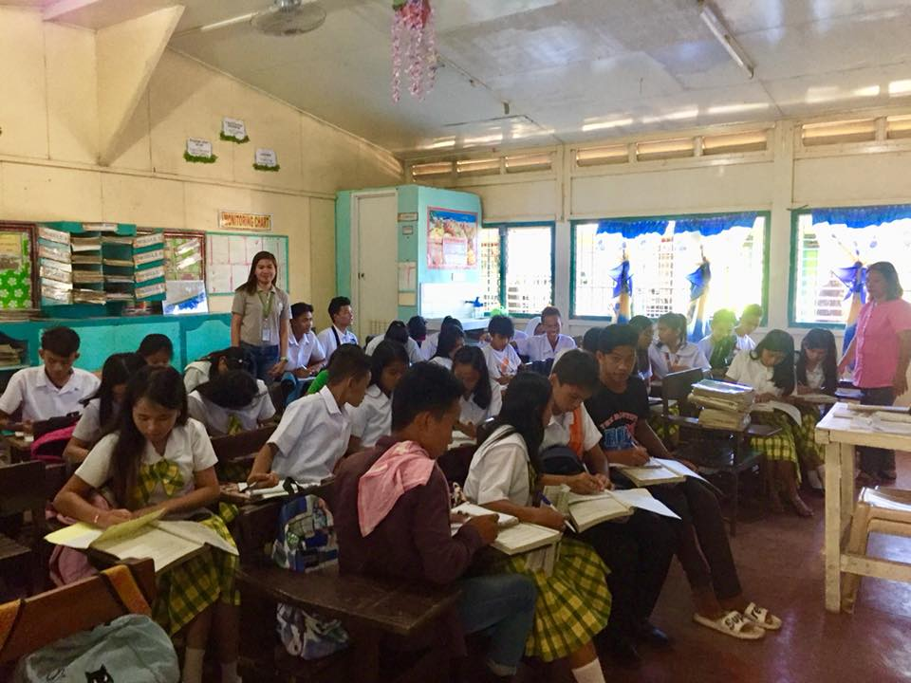

Field Study 5, Episode 1-7

Tasks | Exemplary  4 | Superior  3 |  | Satisfactory  2 | Unsatisfactory  1
Documentation: | All the tasks were done with outstanding quality; work exceeds expectations  4 | All or nearly all tasks were done with high quality  3 |  | Nearly all tasks were done with acceptable quality  2 | Fewer than half of tasks were done; or most objectives met but with poor quality  1
My Analysis/observation | Analysis questions were answered completely; in depth answers; thoroughly grounded on theories  Exemplary grammar and spelling.  4 | Analysis questions were answered completely  Clear connection with theories  Grammar and spelling are superior  3 |  | Analysis questions were not answered completely.  Vaguely related to the theories.  Grammar and spelling acceptable  2 | Analysis questions were not answered.  Grammar and spelling unsatisfactory.  1
My Reflection | Reflection statements are profound and clear, supported by experiences from the episode.  4 | Reflection statements are clear, but not supported by experiences from the episode.  3 |  | Reflection statements are shallow; supported by experiences from the episode.  2 | Reflection statements are unclear and shallow and are not supported by experiences from the episode.  1
My Portfolio | Portfolio complete, clear, well-organized and all supporting documentation are located in sections clearly designated.  4 | Portfolio is complete, clear, well-organized and most supporting documentation are available and/or in logical and clearly marked locations.  3 |  | Portfolio is incomplete; supporting documentation is organized but is lacking.  2 | Portfolio has many lacking components; is unorganized and unclear.  1
Submission | Before deadline  4 | On the deadline  3 |  | A day after the deadline  2 | Two days or more after the deadline  1
Subtotals
Over-all Score |  |  | Rating: (Based on  Transmutation)
Signature of FS Teacher  Above Printed Name |  |  | Date
